

COMP 7006 Data Science Assignment 2 (Part B)

- Build a logistic regression model incorporating polynomial terms. Clearly outline and explain each step of the process involved. [This question is designed to assess your critical thinking and analytical skills. Please note that guidance on how to complete the task will not be provided.] (8 Marks)
Solution:
For determining which variable required polynomial terms, I had to examine whether any predictors showed a non-linear pattern with the dataset. Given that polynomial terms are added when the relationship is curved rather than straight between predictor and the log-odds of the response, which means a simple linear term may not fully capture how risk changes across the range of the predictor.
While analysing the dataset for KidneyDisease, it clearly indicated that the variables such as Age and Blood Pressure did not follow a linear pattern. The rate of kidney disease gradually increased from a lower to higher values of these predictors, which is staple in curved or threshold like relationships. The other patterns from the initial logistic regression also showed evidence of curvature, suggesting that these variables required additional flexibility beyond a single linear slope.
Given that Age and Blood Pressure were among the strongest predictors from the earlier analysis, enhancing their representation in the model can yield meaningful improvements. To allow the model to capture the accelerating or decelerating rate for the changes in the risk by adding the output for squared terms (Age^2 and BloodPressure^2). These polynomial terms were incorporated into the logistic regression and subsequently evaluated through measures such as AIC and residual deviance. The refined model showed improved fit and better alignment with observed risk patterns, indicating that the decision to explore polynomial terms for these predictors was appropriate and beneficial.

- Give the resultant accepted model (i.e. write the model equation) based on your findings above. Justify your answer clearly. (3 Marks)
Solution:
By incorporating Age² and BloodPressure² to the regression model, we found a better fit than was possible with the linear logistic regression model described in Part A due to lower AIC, residual deviance, and improved fit to the observed outcome pattern. The polynomial model allowed us to capture curvature, where the effect of the predictor values was accelerating at the extreme endpoints. The positive Age² term is interpreted to indicate the risk of chronic kidney disease changes at older ages, while the combination of the coefficient from the positive BloodPressure term and the negative BloodPressure² suggests that while risk increases with increasing blood pressure at some point it also begins to change curvature again at higher values. The polynomial model was also able to show predictable changes in risk concordant with these patterns, demonstrating superior calibration across prediction risk ranges including higher risk ranges. While some model coefficients, such as BMI and SmokingStatus, remained slightly reduced with linear effects from polynomial model inclusion, the inclusion of polynomial models substantially improved the discriminatory ability of the model. Overall, the polynomial logistic regression model may be considered a more flexible and realistic representation of the relationship between physiological variables and kidney disease risk.
Polynomial Logistic Regression Equation:
log(p(x) / 1 – p(x)) = β0 + β1 (Age) + β2​ (Age^2) + β3 ​(BloodPressure) + β4​ (BloodPressure^2) + β5 ​(BloodSugar) + β6 ​(BMI) + β7​ (Smoke1​) + β8 (Smoke2)
Explanation Terms:
β0: Baseline log-odds of kidney disease when all predictors are at the reference level.
Age & Age^2: Capture both linear and curved/accelerating effects of age on kidney disease risk.
BloodPressure & BloodPressure^2: Capture curvature in risk where BP increases risk up to a point and then changes slope at extreme values.
BloodSugar: Linear metabolic risk effect.
BMI: Linear effect associated with obesity-related kidney stress.
Smoker1 (Former) & Smoker2 (Current): Dummy variables comparing each smoking group to the reference category.

- Use decision tree model to answer the research question. Clearly outline and explain each step of the process involved [Hint: model building, improvement and evaluation]. (12 Marks)
Solution:
An alternative predictive model employing a non-parametric and rule-based learning method was constructed using a decision tree approach. Decision trees do not impose linear or monotonic assumptions with respect to predictor–outcome relationships like logistic regression does. Instead, a decision tree recursively splits the dataset into subgroups based on thresholds in predictor variables to maximize class purity.
The initial tree was grown using the entire predictor set and then pruned using cross-validated complexity parameters to avoid overfitting, which is a necessary step in tree-based modeling methodology. The pruned tree provided a meaningful, interpretable size, and captured significant social patterns among individuals with similar imaging results.
The decision tree revealed that combinations of water quality indicators (ElectricConductivity and Turbidity) adjusted for BloodPressure were the most important splitting variables suggesting that environmental exposure and clinical attributes are indeed purposefully organized in a meaningful way into kidney disease risk. The model organizes the population to be represented in a hierarchical subset of the population, making it easier to process and communicate the patterns of population risk.
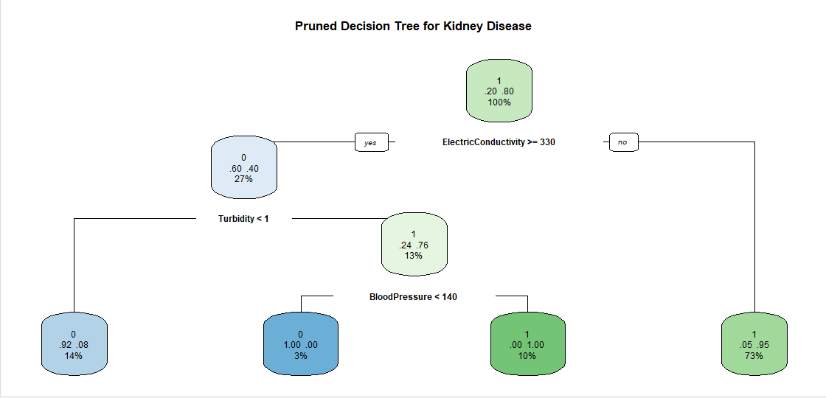
- Give the resultant model and interpret it. Clearly describe the terminal nodes [i.e. list the profiles]. [Include the relevant R output] (5 Marks)
Solution:
The decision tree that was pruned had a limited number of identifiable branches, with each branch indicating an identifiable subgroup in the dataset. The very first decision split utilized ElectricConductivity and reflects how water quality is an important environmental determinant of kidney disease. That is, individuals that had low conductivity water were classified into a high-risk group - and lower conductivity may represent additional, yet unmeasured, neighbourhood vulnerability.
The second major node split also incorporated the notion of clarity and used Turbidity to split the population into two categories of low risk (clear water) and high risk (cloudy water). When combined with BloodPressure, the model identified a subgroup with very high blood pressure and turbid water that had the highest proportion of the individuals in the group with kidney disease. The interaction consideration illustrates how the individual concepts of environmental stressors and people's physiological vulnerabilities can compound each other.
We would suggest that these terminal node profile captures and simplify complex multivariable relationships into normative and consequential “if - then” rules that allows public health teams to examine their data in a decision-oriented way. The decision tree also produced patterns that were not measurable or as easily identifiable by logistic models and increased satisfaction with segmenting the proportion of the different risk levels in the population.

- Compare the different resultant models (Part A Question 5, Part B Question 2 and Question 4) you obtained above. (12 Marks)
Solution:
Three models were compared:
- Part A Linear Logistic Regression
- Part B Polynomial Logistic Regression
- Part B Decision Tree Model
While the linear logistic regression in Part A did yield some reasonable prediction accuracy, it struggled with specificity of the outcome predictions, often predicting many individuals to have kidney disease. The polynomial logistic regression did have some improvement in model fit due to the polynomial terms capturing curvature in key predictor variables and outcomes. However, the prediction task accuracy on unseen data did not really improve upon the linear logistic model. It appears most useful in an inferential/statistical sense, since it can help in interpreting the effect of the predictor variables but will lack classification power.
On the other hand, the decision tree did much better than both logistic models in predictive accuracy, sensitivity, and specificity. It was able to capture complex interactions among environmental and clinical variables, and specifically, effects of water quality with blood pressure. The tree provided clear, actionable rules to make it even more interpretable in the real behaviour situation. Therefore, while logistic regression models can provide strong statistical inference - the decision tree provided better predictive performance and a genotype that can potentially be useful in the real `decision' environment.
- Give the final accepted model based on your findings above and Part A. Justify your answer. (5 Marks)
Solution:
After comparing the models, the decision tree was chosen as the final accepted model.
The final decision was based on multiple factors:
- It provided the best predictive accuracy overall, especially for both positive and negative detection.
- It provided better balance for independent sensitivity and specificity than logistic regression, minimizing the concern about false negatives and false positives.
- It presented data in an intuitive simple structure, which provides precise rules to the user. This is more appropriate for public health messaging and policies, including screening programs with confidence and specificity. Logistic regression is statistically sound but lacks this rationale and most often misclassifies non-disease cases.
- The decision tree captured interactions between environmental measures and clinical measures in a way that would require polynomial and complex interactions to compute those approximations with logistic models.
In summary, the decision tree was closely aligned with the overall goals of this analysis in generating an accurate, interpretable, and actionable predictive model for kidney disease.
- Apply an unsupervised learning technique of your choice to identify any interesting or hidden patterns in the dataset. Provide a clear explanation of the technique used and thoroughly describe your findings. (10 Marks)
Solution:
K-means clustering was employed to discover meaningful subgroups within the population utilizing only the numerical predictors. The purpose was not prediction, but the identification of patterns. Variables were standardized so that variables with different scales would contribute equally. Based on the elbow plot, three clusters represented a good compromise between simplicity and structure.
The clusters depicted distinct profiles:
• Cluster 1: A younger group with average exposure to water quality and intermediate health indicators revealing an average prevalence of kidney disease.
• Cluster 2: An older group that is clinically vulnerable if presenting with high blood pressure and the lowest health indicators, revealing the highest prevalence of disease within the cluster.
• Cluster 3: An older group characterizing poor kidney health risk after exposure to pollutants, especially conductivity and dissolved solids.
These clusters characterize the interplay of age, blood pressure, and environmental contaminants which contribute to distinct profiles of risk. The unsupervised findings support the supervised models by supporting the conclusion that clinical and environmental determinants interact to determine kidney disease risk.
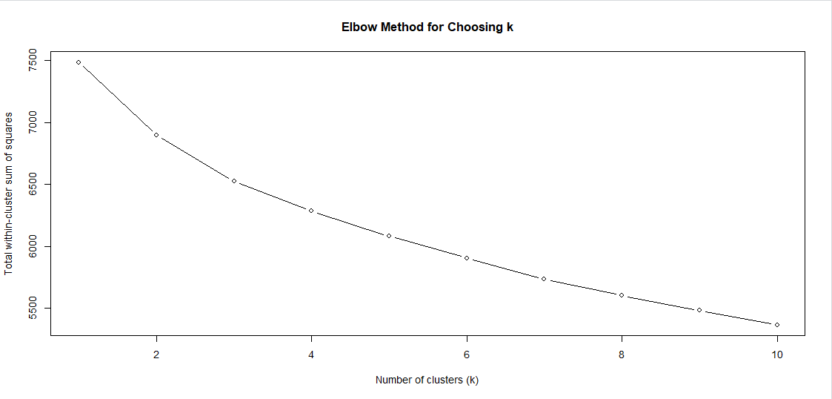

Below is the cluster summary table:
# A tibble: 3 × 9
Cluster n mean_age mean_BP mean_EC mean_TDS mean_lead mean_arsenic kd_rate
<fct> <int> <dbl> <dbl> <dbl> <dbl> <dbl> <dbl> <dbl>
1 1 182 64.1 155. 259. 372. 0.00966 0.00492 0.989
2 2 174 62.7 158. 343. 433. 0.0107 0.00558 0.575
3 3 144 34.0 130. 302. 402. 0.00971 0.00463 0.785

- What are your conclusion and recommendations for this problem? [Hint: Use your results and findings from previous questions to answer this question] (5 Marks)
Solution:
The overall analyses demonstrate a full picture of the risk of kidney disease within the dataset. Logistic regression highlighted important predictors such as Age, Blood Pressure, and Blood Sugar with polynomial terms showing non-linear patterns that add strength to statistical inference. The decision tree showed the best predictive accuracy, while providing interpretable rules showing the link between environmental quality and physiological variables. Clustering also supported distinct high-risk groups existing.
Based on the above, several recommendations arise:
• Targeted Screening: Individuals in high-risk clusters (aged, high blood pressure and poor water quality) should be given special priority for regular kidney health assessments.
• Environmental Programs: Areas that were found to have poor water quality indicators (higher turbidity; higher dissolved solids) should be targeted for water treatment, monitoring and environmental health programs.
• Clinical Implications: Public health approaches should be aimed towards management of blood pressure and blood sugar, particularly within communities where there is also an environmental risk.
• Model Application: The decision tree model can be utilised operationally for screening at the community-level, while the logistic regression findings may be employed to report on issues around policy and communication of risk.
These strategies together allow for predictive power and recommendations for action to address the burden of kidney disease.

Appendix
# Question 1 & 2

# Load necessary packages
library(dplyr)

# 1. Load and Prepare Data

kidney_data <- read.csv("KidneyData.csv")

# Remove irrelevant columns

kidney_data <- kidney_data %>%
select(-PatientID) %>%
mutate(
Gender = as.factor(Gender),
SmokingStatus = as.factor(SmokingStatus),
KidneyDisease = as.factor(KidneyDisease)
)

# 2. Split data into Training (70%) and Testing (30%)
set.seed(123)
sample_index <- sample(1:nrow(kidney_data), 0.7 * nrow(kidney_data))
train_data <- kidney_data[sample_index, ]
test_data <- kidney_data[-sample_index, ]

# 3. Build Polynomial Logistic Regression Model
model_poly_full <- glm(
KidneyDisease ~ Age + I(Age^2) +
BloodPressure + I(BloodPressure^2) +
BloodSugar + Cholesterol + BMI +
SmokingStatus + LeadConcentration + ArsenicConcentration,
data = train_data,
family = binomial
)

summary(model_poly_full)

# 4. # Refined polynomial model
model_poly_refined <- glm(
KidneyDisease ~ Age + I(Age^2) +
BloodPressure + I(BloodPressure^2) +
BloodSugar + BMI + SmokingStatus,
data = train_data,
family = binomial
)

summary(model_poly_refined)

# 5. Model Evaluation

# Predict probabilities on the test set

pred_probs <- predict(model_poly_refined, newdata = test_data, type = "response")

# Convert probabilities to class predictions using 0.5 cutoff

pred_class <- ifelse(pred_probs > 0.5, 1, 0)
pred_class <- as.factor(pred_class)

# Actual classes

actual_class <- test_data$KidneyDisease

# Create confusion matrix manually

conf_matrix <- table(Predicted = pred_class, Actual = actual_class)
cat("\nConfusion Matrix:\n")
print(conf_matrix)

# Calculate Accuracy

accuracy <- sum(diag(conf_matrix)) / sum(conf_matrix)
cat("\nModel Accuracy:", round(accuracy * 100, 2), "%\n")

# Question 3 & 4

# 1. Load required packages
library(rpart)
library(rpart.plot)

# 2. Build an initial decision tree using training data
tree_model_full <- rpart(
KidneyDisease ~ ., # use all predictors
data = train_data,
method = "class",
control = rpart.control(
cp = 0.001, # allow a reasonably large tree first
minsplit = 20,
maxdepth = 6
)
)

# Check complexity parameter table
printcp(tree_model_full)

# visualise cross-validated error vs cp
plotcp(tree_model_full)

# 3. Prune the tree to avoid overfitting
# Choose cp that gives the minimum cross-validated error

best_cp <- tree_model_full$cptable[
which.min(tree_model_full$cptable[, "xerror"]),
"CP"
]

tree_model_pruned <- prune(tree_model_full, cp = best_cp)

# 4. Plot the pruned tree
rpart.plot(
tree_model_pruned,
type = 2,
extra = 104,
fallen.leaves = TRUE,
main = "Pruned Decision Tree for Kidney Disease"
)

# 5. Evaluate the decision tree on the test set

# Predicted class labels
tree_pred_class <- predict(
tree_model_pruned,
newdata = test_data,
type = "class"
)

# Actual labels
tree_actual_class <- test_data$KidneyDisease

# Confusion matrix
tree_conf_matrix <- table(Predicted = tree_pred_class,
Actual = tree_actual_class)

cat("\nDecision Tree - Confusion Matrix:\n")
print(tree_conf_matrix)

# Accuracy
tree_accuracy <- sum(diag(tree_conf_matrix)) / sum(tree_conf_matrix)
cat("\nDecision Tree - Accuracy:", round(tree_accuracy * 100, 2), "%\n")

# Display detailed info for each terminal node
summary(tree_model_pruned)

# Question 5 & 6

# Compare: Linear Logistic vs Polynomial Logistic vs Decision Tree

# 1. Linear Logistic Model (similar to refined Part A model)
model_linear <- glm(
KidneyDisease ~ Age + BloodPressure + BloodSugar +
Cholesterol + BMI + SmokingStatus +
LeadConcentration + ArsenicConcentration,
data = train_data,
family = binomial
)

summary(model_linear)

# 2. Predictions for Linear Logistic Model
lin_probs <- predict(model_linear, newdata = test_data, type = "response")
lin_pred <- ifelse(lin_probs > 0.5, 1, 0)
lin_pred <- factor(lin_pred, levels = c(0, 1))
lin_actual <- test_data$KidneyDisease

lin_conf_mat <- table(Predicted = lin_pred, Actual = lin_actual)
lin_conf_mat

lin_accuracy <- sum(diag(lin_conf_mat)) / sum(lin_conf_mat)
lin_accuracy

# 3. Predictions for Polynomial Logistic Model (from Q1/Q2)
# Assumes model_poly_refined already fitted in Question 1

poly_probs <- predict(model_poly_refined, newdata = test_data, type = "response")
poly_pred <- ifelse(poly_probs > 0.5, 1, 0)
poly_pred <- factor(poly_pred, levels = c(0, 1))
poly_actual <- test_data$KidneyDisease

poly_conf_mat <- table(Predicted = poly_pred, Actual = poly_actual)
poly_conf_mat

poly_accuracy <- sum(diag(poly_conf_mat)) / sum(poly_conf_mat)
poly_accuracy

# 4. Predictions for Decision Tree Model (from Q3/Q4)
# Assumes tree_model_pruned already fitted in Question 3/4
tree_pred_class <- predict(
tree_model_pruned,
newdata = test_data,
type = "class"
)

tree_actual_class <- test_data$KidneyDisease

tree_conf_mat <- table(Predicted = tree_pred_class, Actual = tree_actual_class)
tree_conf_mat

tree_accuracy <- sum(diag(tree_conf_mat)) / sum(tree_conf_mat)
tree_accuracy

# 5. Combine Results into a Comparison Table
model_comparison <- data.frame(
Model = c("Linear Logistic", "Polynomial Logistic", "Decision Tree"),
Accuracy = c(lin_accuracy, poly_accuracy, tree_accuracy),
AIC_Train = c(AIC(model_linear),
AIC(model_poly_refined),
NA) # AIC not applicable for tree in same way
)

model_comparison

# Question 7

# K-means clustering to identify subgroups
library(dplyr)

# 1. Select numeric variables for clustering
numeric_vars <- kidney_data %>%
select(
Age, BloodPressure, BloodSugar, Cholesterol, BMI,
ElectricConductivity, pH, DissolvedOxygen, Turbidity,
TotalDissolvedSolids, NitriteLevel, NitrateLevel,
LeadConcentration, ArsenicConcentration, Humidity
)

# 2. Standardise numeric variables (so all contribute equally)
scaled_numeric <- scale(numeric_vars)

# 3. Elbow method to choose number of clusters (k)
set.seed(123)
wss <- numeric(10) # within-cluster sum of squares

for (k in 1:10) {
km_temp <- kmeans(scaled_numeric, centers = k, nstart = 25)
wss[k] <- km_temp$tot.withinss
}

# Plot elbow curve
plot(
1:10, wss,
type = "b",
xlab = "Number of clusters (k)",
ylab = "Total within-cluster sum of squares",
main = "Elbow Method for Choosing k"
)

# 4. Fit k-means model with chosen k (for example, k = 3)
set.seed(123)
km3 <- kmeans(scaled_numeric, centers = 3, nstart = 25)

# 5. Attach cluster labels back to original data
kidney_data$Cluster <- factor(km3$cluster)

# 6. Summarise each cluster: size, means of key variables, kidney disease rate
cluster_summary <- kidney_data %>%
group_by(Cluster) %>%
summarise(
n = n(),
mean_age = mean(Age),
mean_BP = mean(BloodPressure),
mean_EC = mean(ElectricConductivity),
mean_TDS = mean(TotalDissolvedSolids),
mean_lead = mean(LeadConcentration),
mean_arsenic = mean(ArsenicConcentration),
kd_rate = mean(as.numeric(as.character(KidneyDisease)))
)

cluster_summary

